______________

COVID – A New Dawn Approaches.

But We are NOT There Yet.

__________________________________

Protocols for a Stay at Sonoran Winds
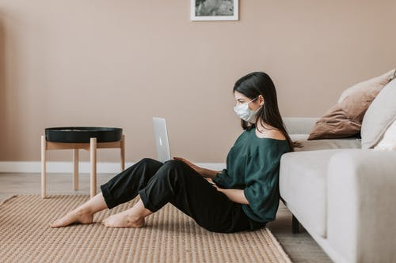
August 6, 2021
Dear Friends,
We are so delighted to share our programming with you, despite the recent pandemic which is now surging again. Hoping everyone had time to relax, create, play, practice, design, and connect with yourself while muddling through and we count our blessings that the vaccine is out there in the world.
Since we are one of the first industries that if officially permitting leniency in the 6 feet of social distancing, since providing personal services is impossible without contact, we are taking extra protocols to ensure that everyone is made safe. Here’s our plan!
- Staff members must self-screen for COVID-19 every day, including measuring the employee’s temperature. Sonoran Winds shall keep records that the screen was completed by having staff members sign a record that the symptom check has been completed. Any employee that exhibits COVID-19 symptoms will be excluded from work.

- All employees and customers must cover their nose and mouth with a face- covering at all times when outside the home.

- Signs (and official Mitigation Protocols, as required by PIMA County) will be posted at the entrance of the home informing all staff members and customers that they must avoid entering the facility if they have a cough or fever, maintain a minimum six-foot distance from one another when possible, sneeze and cough into a cloth or tissue or, if not available one’s elbow, not shake hands, or engage in any unnecessary physical contact.

- Staff members have all signed off on receiving and understanding these Mitigation Protocols prior to being permitted to work.

- Sanitizer stations are available right at the entrance to Sonoran Winds at the front desk, and available throughout the home. All restrooms are supplied with soap and hand sanitizer. Everyone entering our business is asked to please wash or sanitize their hands before greeting guests or employees.

- Other high-touch surfaces will be regularly disinfected and environmental cleaning guidelines from the US Centers for Disease Control and Prevention (CDC) will be followed (e.g., clean and disinfect high touch surfaces daily or more frequently). We always use hospital grade disinfectants.

- Additional time has been allocated in between all services to fully sanitize all counters, chairs, tables, and public areas throughout the home.

- All are advised to honor social distancing standards at all times feasible.

- Doors will be propped open to increase natural air flow, whenever possible.

- COVID air filters are used throughout our business.

COVID-19 Progress Report
The Health Department is tracking the status of COVID-19 in Pima County to make the proper recommendations to business owners and the public about the protective measures currently necessary for slowing or preventing the spread of the virus. We are constantly being updated.
If you have any other questions or thoughts about what we are doing at Sonoran Winds, please call us directly for more information… 917-740-5417.

Blessings on you and your loved ones.

With love, from your family at Sonoran Winds.

